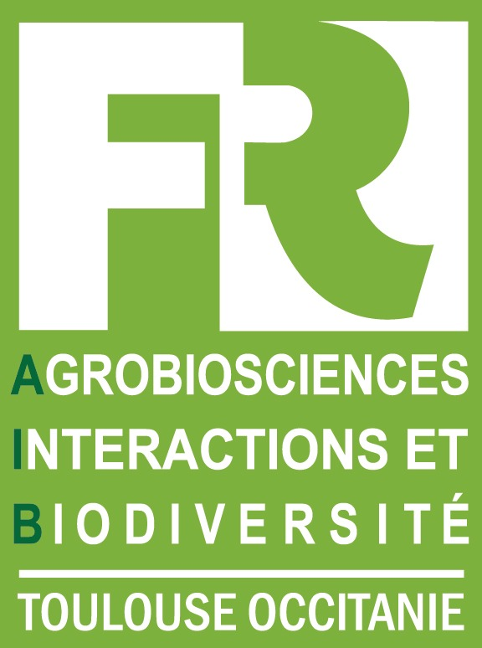
APPEL A PROJETS JEUNES SCIENTIQUES 2019
YOUNG SCIENTISTS PROJECTS 2019

The budget allocated for 2019 is 15 k€ to be shared among the selected projects (maximum 5 k€ /project).

➣Eligibility criteria
• The call is open to doctoral students in 2nd and 3rd year and to post-docs (still under contract until end of 2020)
• The project must be written and carried out by the applicant, with the agreement of the thesis / post-doc contract supervisor
• This call concerns projects requiring specific experiments - including laboratory experiment, field missions - or missions to another laboratory for using a specific technique, developing new theoretical project or for data processing.
• Expenses that are excluded from the call: conference participation fees, publication fees, extension of position contract.

➣ Incentive criteria (not mandatory)

Project applicants are encouraged to use one or more of the 6 platforms from the FR/labs of the FR (Imaging, Proteomics, TPMP, SETE platforms, GeT-PlaGe, MetaToul plant metabolites platform)
➣Submission
Application forms have to be sent to Sophie Guilhem guilhem@lrsv.ups-tlse.fr (with acknowledgment of receipt)
- Dead line of submission: October 2019 21st, 12h. Projects submitted beyond this limit will be rejected.
- Evaluations will be carried out by the scientific committee of the FR AIB according to the criteria reported below.
- Feedback end of October..

➣ Criteria for evaluation
Quality of the project | Scientific relevance  Feasibility in 12 months  Innovative or original  Added value of requested funding
Use of a platform from the FR/labs of the FR*
* not mandatory

ANNEXE : APPEL A PROJET JEUNES SCIENTIFIQUES 2019 : document téléchargeable


APPEL A PROJETS JEUNES SCIENTIQUES 2019 / YOUNG SCIENTISTS PROJECTS 2019
Date limite de retour : 21 octobre 2019 midi / deadline : October 21, 2019 at noon
• Project title and acronym

• Investigator’ name, laboratory and current position (with start and end dates)

• If appropriate: Use of a platform
Imagerie FR ▢ Protéomique FR ▢ TPMP ▢ Plateformes “SETE” ▢
GeT-PlaGe ▢ Plateau métabolites végétaux de MetaToul ▢
• Project description (scientific context, objectives, approaches, budget). Added value of the grant and the use of platforms in the PhD / post doc project 2 pages max

on separate pages

• Agreement of thesis supervisor/PI and signature

To supervisors: please, note that the project has to be written and carried out by the applicant (PhD student/postdoc), not by you.

